Cellular Network

📱 What Is a Cellular Network?
# Source: AI Source: Provided by: [Data Path: Persons Table -> ID Column: 1, Name_En Column: Motasem Essam] -> From: [ChatGPT] on [1/23/2026]
A cellular network is a type of wireless communication system that divides a large area (like a country or city) into smaller regions called "cells" — each served by a cell tower (base station) — to provide mobile phone and internet service.
It’s the backbone of mobile communication, allowing people to make calls, send texts, and use mobile data on the move.

🧱 How It Works (Simplified):
# Source: AI Source: Provided by: [Data Path: Persons Table -> ID Column: 1, Name_En Column: Motasem Essam] -> From: [ChatGPT] on [1/23/2026]
- 📱 Your phone connects to the nearest cell tower using radio waves.
- 📡 The tower forwards your call/data to a mobile switching center (MSC).
- 🌐 The MSC connects you to the internet or another phone.
- As you move, your phone switches to nearby towers automatically (called a handover).

🗺️ Why It’s Called “Cellular”:
# Source: AI Source: Provided by: [Data Path: Persons Table -> ID Column: 1, Name_En Column: Motasem Essam] -> From: [ChatGPT] on [1/23/2026]
- The coverage area is divided into hexagonal cells.
- Each cell has its own frequency and tower.
- This allows reusing frequencies in non-adjacent cells → more users with less interference.

🔑 Key Components of a Cellular Network:
# Source: AI Source: Provided by: [Data Path: Persons Table -> ID Column: 1, Name_En Column: Motasem Essam] -> From: [ChatGPT] on [1/23/2026]
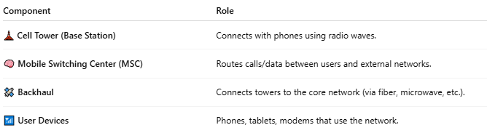

Component | Role
🗼 Cell Tower (Base Station) | Connects with phones using radio waves.
🧠 Mobile Switching Center (MSC) | Routes calls/data between users and external networks.
🛰️ Backhaul | Connects towers to the core network (via fiber, microwave, etc.).
📶 User Devices | Phones, tablets, modems that use the network.

📶 Cellular Network Generations:
# Source: AI Source: Provided by: [Data Path: Persons Table -> ID Column: 1, Name_En Column: Motasem Essam] -> From: [ChatGPT] on [1/23/2026]
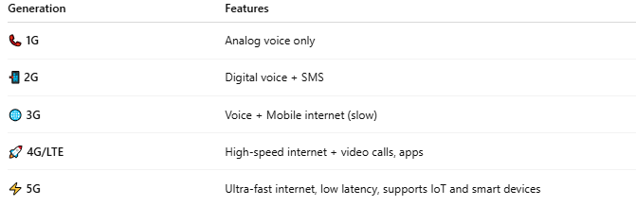
Generation | Features
📞 1G | Analog voice only
📲 2G | Digital voice + SMS
🌐 3G | Voice + Mobile internet (slow)
🚀 4G/LTE | High-speed internet + video calls, apps
⚡ 5G | Ultra-fast internet, low latency, supports IoT and smart devices

📖 Summary:
# Source: AI Source: Provided by: [Data Path: Persons Table -> ID Column: 1, Name_En Column: Motasem Essam] -> From: [ChatGPT] on [1/23/2026]
A cellular network is a system of connected cell towers that allows your mobile device to send and receive calls, texts, and internet data wirelessly. It’s the reason you can use your phone while moving anywhere — in your home, on the street, or across cities.

